VS-35 Blue Wolves
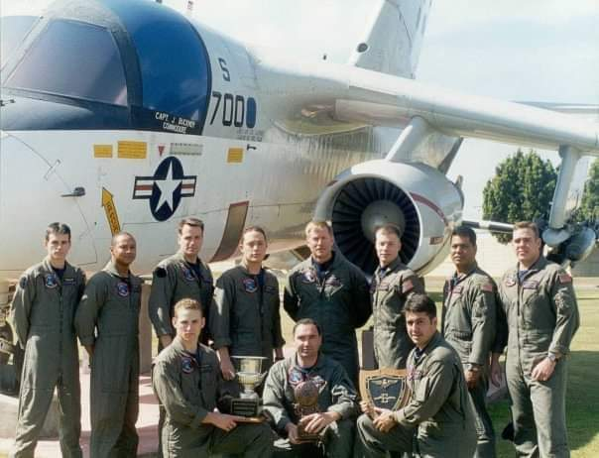
1999 Front Row l to r: Shane Anderson, Todd Harris, Travis Lorenz
Back Row l to r: Tim Holland, Jason Wimbish, Mike Wilder, Cam Peterson, Jim Hunnewell, Dan Buerger, Ian McElwain, Brandon Talbot

