A Tale of Two SENSOs

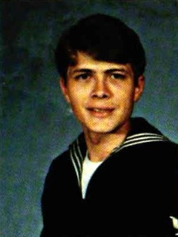
Back around the middle of 2022, a couple of old SENSOs got together for some drinks and reminiscing. Although to some, that might sound like a recipe for disaster, something amazing actually came of these two SENSOs talking on the phone, “sipping” cocktails and coming up with “good” ideas. Blair Smith has lived in Las Vegas for years now, but occasionally he would find himself in the San Diego area for short visits and he always made it a point to look in on some of his squadron mates from when he served in VS-41 as an instructor and VS-37 and VS-29 as a fleet SENSO. This time the connection came over Facebook. Jay Blinn who had served with Blair at VS-41 while also spending time in the fleet at VS-21, had written a remembrance of Dave Wein, another fellow SENSO(VS 41 and VS 32) on the anniversary of his passing in 2018. Jay and his wife Susan had stayed close to Dave over the years and would occasionally stop by Primavera in Coronado where Dave tended bar with a flair and spirit only a SENSO could conjur up. In Jay’s words, “It was like the bar was his stage and he put on a show every night.”
Dave Wein
Blair saw the remembrance Jay posted and reached out to him. Blair and Jay lamented Dave’s passing and looked back on some others who were also gone. As they toasted their friends now departed, they realized that this trend was only going to accelerate as time passed. They would lose more and more old friends from their SENSO days.

Legend has it that during that call, Jay was the one who first spoke the words “It sure would be great to get some of the ol’ gang together before we are all either gone or too old and decrepit to travel (or words to that effect).” All of a sudden the mood shifted as more drinks were “sipped” and the two men were energized by an idea. Let’s get the band back together! Because they had served together as instructors, they thought it would be fun to get some of the SENSO instructors together right there in San Diego for a small reunion. From there the ideas bounced back and forth, with thoughts of honoring those who had passed while reconnecting those who were still around. As the tale goes, Jay made a masterful strategic move right then and there when he looked through the phone straight into Blair’s SENSO soul and said “Blair you are the perfect person to put this together. I will assist with any financial needs and, shoot, I will even take people out on my boat, but you are the guy that should plan this (again, he said something like that).”
Of course, Blair being Blair, he jumped at the challenge and took it on with all of his heart and soul. The two old friends called it a night, excited that they would be able to get nine or ten guys together for a fun weekend. Blair returned to Vegas, the TF34s in his head already coming up to full power as he thought how to do this. Being an incredible leader and a meticulous planner, Blair knew he would need a team to bring this to reality. Over the next few weeks, he reached out to some other SENSO instructors he knew would answer the call. Eventually he had a team of Don Branagan, Brett Robinette, Jorge Rodriguez and Scott Murdock. They chose Memorial Day Weekend 2023 for the reunion in Coronado. This was going to happen.

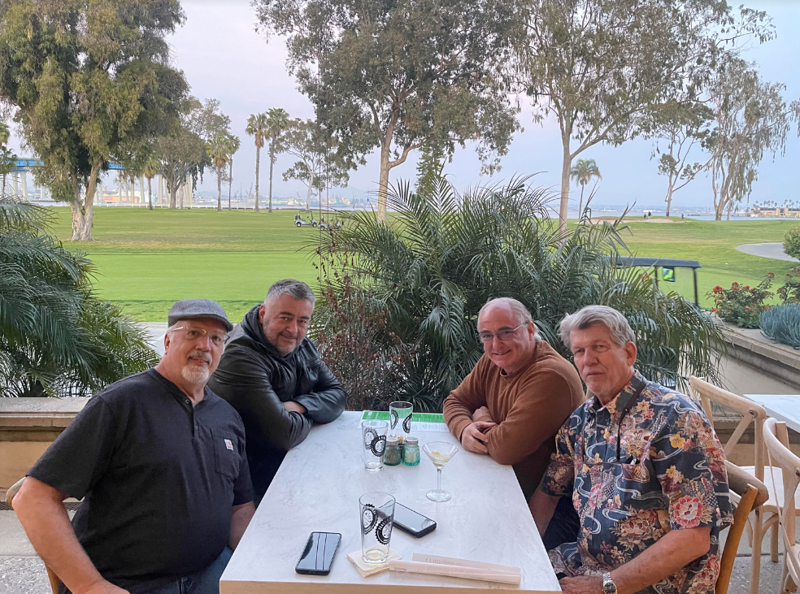
Don Branagan, Scott Murdock, Blair Smith and Jay Blinn finalyze plans for the 2023 reunion

One of the largest and more difficult tasks was chasing down all of the SENSO instructors and making contact with them. Blair broke out the rolodex and started a spreadsheet with those he had contacted, those where were MIA and those who had passed. It didn’t take long to see that this wasn’t going to be nine or ten guys getting together for some beers. The interest was overwhelming so the team put together an ambitious schedule of events that would bring the band together in full force. When all was said and done, there were almost 100 SENSOs and significant others together in the San Diego area over Memorial Day weekend. The reconnection with friends past and present was amazing and the recognition of those who had taken their last flight beyond the horizon was heartfelt and touching.
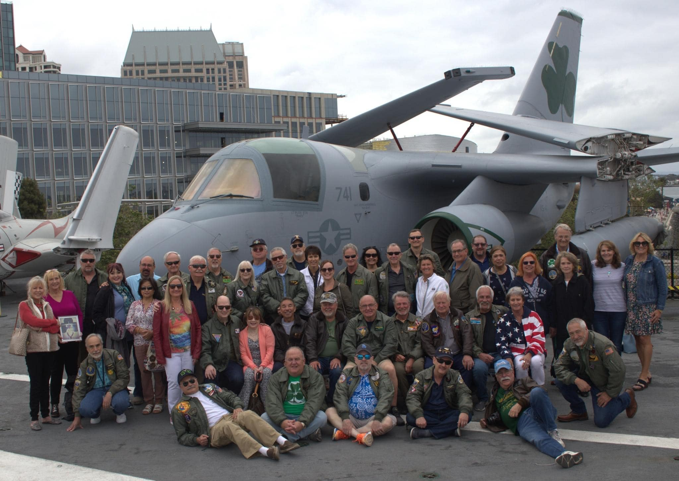
Memorial Day Weekend 2023 onboard USS Midway

No sooner had the reunion finished then the reunion committee, now bolstered by the addition of Justin Jones, Mark Hall and Karen Maule, decided the next reunion had to be for all AWs who had served as SENSOs in the S-3 community. Still drunk on the success of the first reunion, they decided to make it bigger and better in 2025. Beyond the reunion committee, and to facilitate a better experience, a non-profit organization, Viking SENSO Association has been formed and is awaiting final approval for official c(19) non-profit status. A board was formed with Marty Nielsen, Blair Smith, Don Branagan, Karen Maule and Scott Murdock as the initial board. The reunion committee continues to grow with Randy Tyle, George Capestany, Greg Bules and Tim Fagan joining the effort.
So, yeah. That is what happens when a couple of old SENSOs get together to reminisce over a few drinks. Viking SENSO Reunion 2025 here we come! See you August 7-10, 2025 in San Diego!

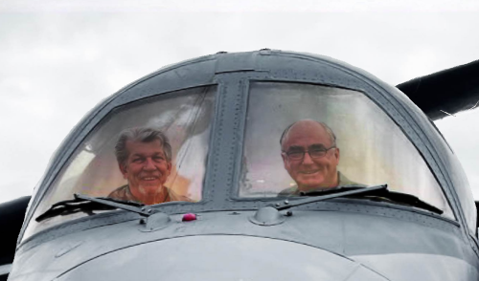
Jay Blinn and Blair Smith coming up with ideas

